Configure Azure Monitor for the AKS-based application, creating alerts for CPU and memory thresholds.

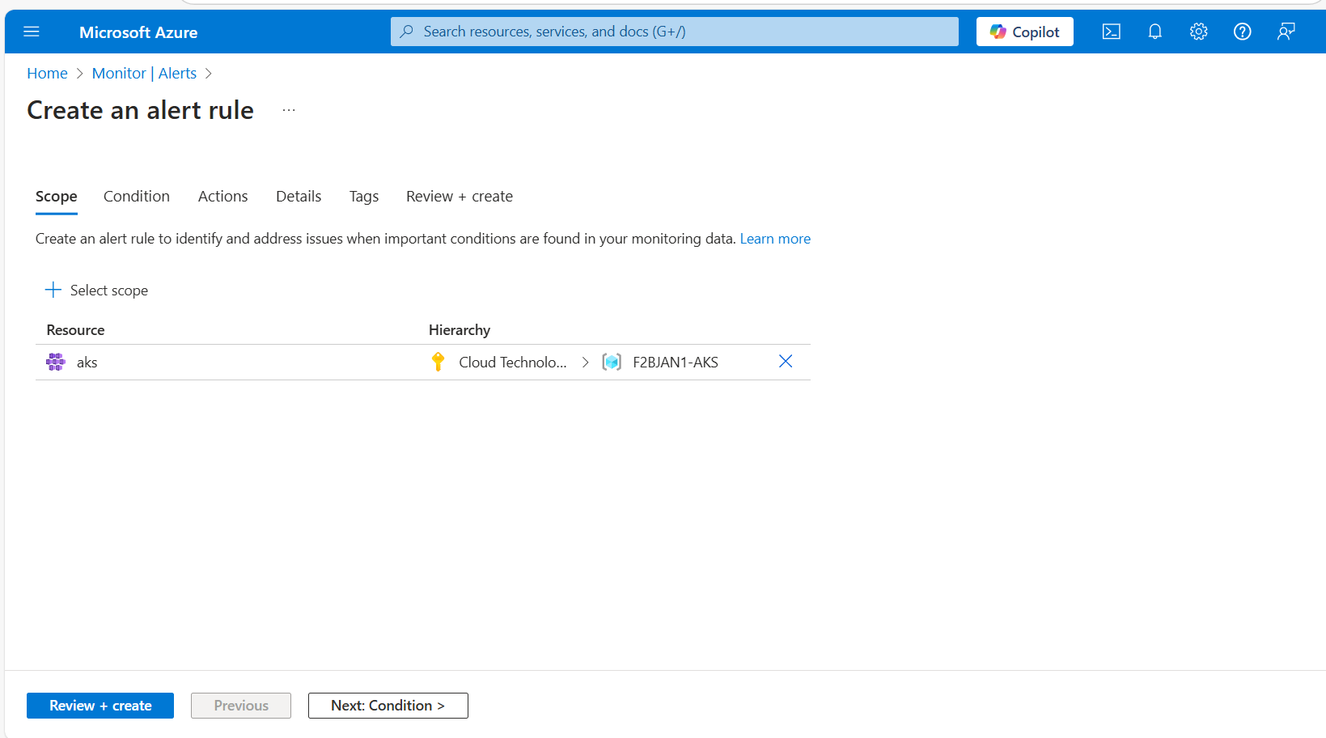

Set the **Threshold** for when the alert should trigger. For example:

* CPU > 80% for 5 minutes
* Memory > 80% for 5 minutes

